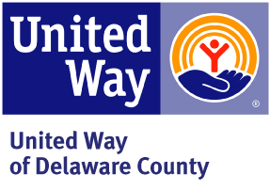
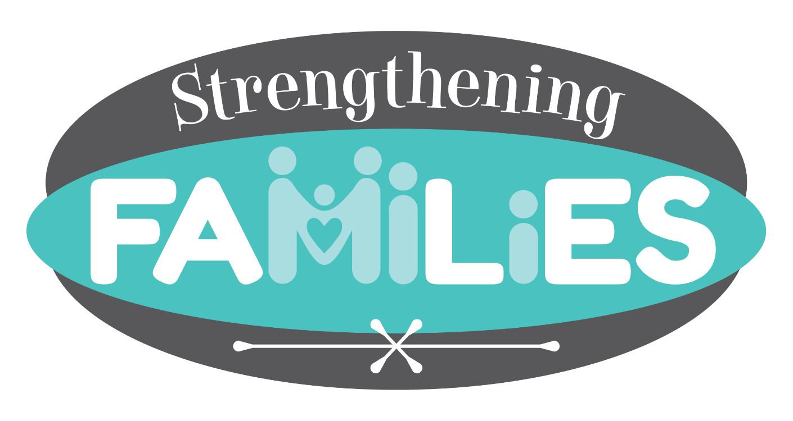

2017-2021 Strategic Plan
Table of Contents
INTRODUCTION 2
MISSION STATEMENT 2
VISION STATEMENT 2
TAGLINE 2
2015-2016 STRATEGIC PLANNING PROCESS 3
BACKGROUND & COLLECTIVE IMPACT 3
PILOT PROGRAM 4
PARTICIPATING AGENCIES 4
STRENGTHENING FAMILY INITIATIVE PRIORITIES 5
EARLY CHILDHOOD EDUCATION 5
AFTERSCHOOL PROGRAMMING 6
ACTION PLANNING TEMPLATE 8
REFERENCES 9

INTRODUCTION
The purpose of this document is to outline a five-year plan for the Strengthening Families Initiative, guided by key community stakeholders from our local schools and direct service providers. This plan is intended to serve as a roadmap during the early stages of this project.

MISSION STATEMENT
To empower Delaware County residents through lifelong learning using a collective approach.

VISION STATEMENT
The Strengthening Families Initiative enhances the lives of Delaware County residents through comprehensive programming and collaborations.

TAGLINE
Families Learn, Grow and Thrive

2015-2016 STRATEGIC PLANNING PROCESS

BACKGROUND & COLLECTIVE IMPACT
Collective impact is the idea that significant and lasting impact is achieved through common goals and metrics in a multi-sector strategy by harnessing community resources including money, expertise, and staff/volunteers. The United Way of Delaware County has been moving to a collective impact model for several years and has committed to fully implementing coordinated strategies to address top community needs related to the Strengthening Families Initiative.
The Strengthening Families Initiative partners provided general direction for the strategic planning process. The United Way of Delaware County convened the initial meeting with local school district nurses, guidance and behavior professionals, and school resources officers. The meeting was attended by United Way staff and five subject matter experts from Big Walnut Local Schools, Olentangy Local Schools, Delaware City Schools, and the Delaware Area Career Center. During this time, attendees reviewed the 2015 United Way of Delaware County Community Needs Assessment (CNA) and contributed observations on the most pressing matters for Delaware County children.
In addition, United Way of Delaware County also participates with the local community coalition, Partnership for a Healthy Delaware County (The Partnership). The Delaware General Health District provides strategic guidance for this community collaboration to complete a community health assessment (CHA) every five years per the Ohio Revised Code. The purpose of completing a CHA is to:
- Assist local public health partners in assessing resident health status
- Analyze community health data to prioritize health issues
- Create a community health improvement plan (CHIP) to impact selected priorities (currently in the middle of a five year cycle, 2014-2018)

United Way of Delaware County is an active member of the Partnership and referenced multiple health assessments in the creation of their own 2015 Community Needs Assessment.

Once the assessment phase was complete in 2015, members of The Partnership prioritized health issues for both adults and youth. As noted below, many of the same priorities showed up in both the United Way’s CNA and the Health District’s CHA. Since many of the same priorities were identified by the overlapping work of both the Health District and the United Way, both agencies agreed to pool their resources to address these community themes. The Strengthening Families initiative has integrated the Family Support priority from the CHA and has taken the lead role in the community to provide families the support they need in the areas of mental health, early childhood education readiness, and afterschool programming.
Subsequent meetings with community partners were held to utilize the information provided by the subject matter experts and the CNA to select priorities for the Strengthening Families Initiative:
• Early Childhood Education
• Afterschool Programming

PILOT PROGRAM
The Strengthening Families Initiative 2017-2021 Strategic Plan is intended to give guidance to the pilot phase of this new program and will serve as a living, fluid document. Within the first year, programming will begin in the Willis Educational Centers, as per the agreement between the United Way of Delaware County and Delaware City School District. In subsequent years, opportunities for the expansion of programs to be conducted outside of the center will be explored. During the pilot phase, the participating agencies will adjust this plan as necessary to accommodate effective programming and partnership that will be sustainable following the end of the pilot phase.

PARTICIPATING AGENCIES

o Action for Children
o Big Brothers Big Sisters
o Blessings in a Backpack
o Buckeye Valley Local School District
o Big Walnut Local School District
o Delaware Area Career Center
o Delaware City Police Department
o Delaware City School District
o Delaware County District Library
o Delaware County Jobs and Family Services
o Delaware County Juvenile Courts
o Delaware General Health District
o Delaware Speech and Hearing Center
o Delaware-Morrow Mental Health & Recovery Services Board
o Directions for Youth and Families
o Drug Free Delaware
o Family Resource Center
o Girl Scouts of Ohio’s Heartland
o Help Me Grow
o HelpLine
o LEADS Head Start
o Liberty Community Center
o Maryhaven
o Mid-Ohio Psychological Services
o Olentangy Local School District
o Second Ward Community Initiative

STRENGTHENING FAMILY INITIATIVE PRIORITIES

EARLY CHILDHOOD EDUCATION

“BY 2021, INCREASE THE NUMBER OF STUDENTS ENTERING KINDERGARTEN WITH AGE APPROPRIATE SOCIAL EMOTIONAL SKILLS BY 6%”

BASELINE MEASUREMENT
In 2015, 91% of Delaware County students did not require intensive intervention and instruction following the Kindergarten Readiness Assessment (KRA-L)*, which is reflective of the social-emotional capabilities of children entering kindergarten. This assessment is administered statewide yearly (Early Childhood Advisory Council, 2015). The intent is to increase this number to 97%.
*Westerville City Schools was included in the 2015 KRA-L data for Delaware County.

STATEMENT OF NEED
The Strengthening Families Initiative partners chose to focus on social emotional development for children ages birth to five.
Research indicates the foundation to long-term social and academic success is the early development of self-regulatory and social competency skills (National Conference of State Legislatures, 2005).
The CNA lists “Families in constant crisis” as a priority. By encouraging participation in early childhood education, long-term success increases. By focusing on social emotional development, the early childhood education goal also encompasses the CNA “Access to mental health” priority.

STRATEGIES AND STRATEGY OBJECTIVES
- Provide opportunity to identify social emotional needs by increasing availability of evidence-based assessments.

Strategy Objective: By 12/31/2018, provide the administration of the Devereux Early Childhood Assessment (DECA). This recognized best practice is designed to build resilience in children ages 3 to 5 and includes strategy guides for parents and instructors following the assessment.

- Gather baseline data on existing DECA and ASQ programs
- Administer daycare providers’ roundtable
- Provide opportunities for trainings

- Offer access to mental health services.

Strategy Objective: By 08/31/2017, establish readily-available resources to address mental health issues and make referrals to the appropriate supportive agencies.

- Provide access to Nationwide Children’s Hospital resources
- Provide access to center-based referral program

- Create a learning environment for children and parents.

Strategy Objective: By 12/31/2018, provide a program designed to build knowledge, skills and capacity among families. This program will be designed to intentionally build effective partnerships between providers and families and increase family engagement.

- Provide a toy library
- Implement a plan to install pilot Born Learning Trails
- Provide web-based parent resource hub

AFTERSCHOOL PROGRAMMING

"BY 2021, INCREASE GRADES SIX THROUGH EIGHT STUDENTS ENGAGED IN STRUCTURED AFTER SCHOOL ACTIVITIES (PERCENTAGE TO BE DETERMINED BY 2017 YRBS DATA).

BASELINE MEASUREMENT
The Youth Risk Behavior Survey is administered to middle and high school students in Delaware County. Questions regarding Afterschool Programming will be added to the survey to establish baseline data and continue to be tracked through 2021.

STATEMENT OF NEED
The Strengthening Families Initiative partners have selected middle school engagement to be the focus for after school programming. Research shows that arts programs can decrease delinquent behavior and aid in the development of positive problem-solving and communications skills (Americans for the Arts, 2003; The National Governors Association, 2002). Studies show us that students participating in a high quality after school programs have increased school attendance, improve positive behavior, and perform at a higher academic level compared to non-participating students (After School Alliance, 2012).
Approximately 14% of Delaware County Students did not pass the Ohio Reading Achievement Assessment in 2013-14, and approximately 20% did not pass the Ohio Math Achievement Assessment, both given to students grades three to eight. A total of 20% of these students – more than 800 students – are at risk of academic failure and would benefit from afterschool programming.
The CNA listed “Mentorship opportunities for youth and young adults” as a priority. By encouraging participation in afterschool activities, long term success increases. Because afterschool programming is shown to help adolescents make better choices, the afterschool programming goal also encompasses the CNA “Heroin and opiate abuse” priority.

STRATEGIES AND STRATEGY OBJECTIVES

- Utilize subject-matter experts to guide afterschool programming.

Strategy Objective: By 10/31/16, convene an afterschool programming subcommittee to decide upon and expand into comprehensive, coordinated strategies and objectives amongst providers and school.
- Convene agency year-round committee with middle school youth leadership representative components (After SF allocations determination).
  - Investigate brainstormed focus group, survey, and agency committee recommendations for additional programming.
  - Develop Willis Center guiding principles.
- Grow Mental health drop-in concept including policies and procedures.

- Develop measurement tools to gather data from programs and/or schools regarding:
  - Baseline data (2017) regarding afterschool involvement from Youth Risk Behavior Survey measured against 2021 data.
  - #of hours spent in mentorship.
  - School attendance, tardiness, # of office referrals.

- Provide opportunities for children to try new and diverse activities.

Strategy Objective: Provide on-going engagement opportunities both long-term and intermittent which support experiential learning, mentorship (both community and individual), and self-confidence and pro-social activity (mental health).
- Conducted middle school student focus groups and surveys to assess the needs of afterschool programming.
- Connect long-term programming with complimenting short-term opportunities, activities, and events at the Willis Center.
- Provide a welcoming, inclusive atmosphere/system at Willis Center & other after-school programming models.

action planning template
Goal #1:
Outcome Objective #1:
Strategy #1:
Evidence-base:
Policy, System, Environmental Change:
Align with State/ National Priorities:
Barriers:
Assets & Resources:
Strategy Objective #1:
Performance Measures:
Baseline:
Action Steps | Responsible  Agency(s) | Resources  Required | Time Frame |  | Performance measure
1.
2.
3.

REFERENCES
Action for Children. Progress Made. Ground Lost. A Comprehensive Report on Early Child Care in Franklin County. Columbus, OH: Community Research Partners, 2012. Print.
Allen, Mary Dallas and Beth L. Green. "A Multilevel Analysis Of Consultant Attributes That Contribute To Effective Mental Health Consultation Services". Infant Mental Health Journal 33.3 (2012): 234-245. Web.
Delaware General Health District. 2014 Youth Health Assessment. Delaware, OH. 2014. Print.
Delaware General Health District. Delaware County Health Improvement Plan 2014-2018. Delaware, OH. 2014. Print.
Delaware-Morrow Mental Health & Recovery Services Board. Fiscal Year 2017-2018 Strategic Plan. Delaware, OH. 2016. Print.
Division for Early Childhood. (2014). DEC recommended practices in early intervention/early childhood special education 2014. Retrieved from http://www.dec-sped.org/recommendedpractices
National Conference of State Legislatures. Helping Young Children Succeed: Strategies To Promote Early Childhood Social And Emotional Development. Denver, CO: National Conference of State Legislatures, 2005. Print.
LeBuffe, Paul A. and Jack A. Naglieri. "The Devereux Early Childhood Assessment (DECA): A Measure Of Within-Child Protective Factors In Preschool Children". NHSA Dialog: A Research-to-Practice Journal for the Early Intervention Field 3.1 (1999): 75-80. Web.
Early Childhood Advisory Council. Delaware County. Early Childhood Advisory Council, 2016. Print. Early Learning and Development County Profile.
O'Connell, Mary Ellen, Thomas F Boat, and Kenneth E Warner. Preventing Mental, Emotional, and Behavioral Disorders among Young People. Washington, D.C.: National Academies Press, 2009. Print.
Office of Head Start, U.S. Department of Health and Human Services. Social Emotional Tips for Providers Caring For Toddlers. Lake Orion, MI: N.p., 2016. Print.
Office of Head Start. Competencies: Infant/Early Childhood Mental Health Consultation. Print.
"Ohio Department of Mental Health & Addiction Services > Supports > Children, Youth & Families > Early Childhood". Mha.ohio.gov. N.p., 2016. Web. 23 July 2016.
Ozanne, Lucie K and Julie L Ozanne. "A Child's Right to Play: The Social Construction of Civic Virtues in Toy Libraries". 30.2 (2011): 264-278. Web.
Parent Services Project,. Parent Services Project 2013 Annual Report. San Rafael, CA: N.p., 2016. Print.
Smooth Transitions: Post-Secondary Education and Mental Health Issues. Columbus, OH: Ohio Department of Education, 2016. Print. Project Aware Ohio Information Brief.
United Way of Delaware County. 2015 Community Needs Assessment. Delaware, OH: United Way of Delaware County, 2015. Print.

